**Nader S. Opeyany**

**Cisp 440**

**9/29/19**

Assignment 4

Question1 :

Let A = {2, 3, 4} and B = {6, 8, 10} and define a relation R from A to B as

follows: For all (x, y) ∈ A × B,

(x, y) ∈ R means that y / x is an integer.

a. Is 4 R 6? Is 4 R 8? Is (3, 8) ∈ R? Is (2, 10) ∈

R?

b. Write R as a set of ordered pairs.

c. Write the domain and co-domain of R.

d. Draw an arrow diagram for R.

Answers:

1. 4 doesn’t have the relationship with 6, 6 does have the relationship with 8, (3,8) is not within the

Relationship as its defined ,(2,10) is within the relation ship as its defined.

b.R={(2,6);(2,8);(2,10);(3,6);(4,8)}

c.Domain:{2,4,6} co-Domain:{6,8,10}

d.

2

3

6

6

8

10

Question2 :

Let C = {1, 2, 3, 4} and D = {a, b, c, d}. Define a function G: C → D by the following arrow diagram:

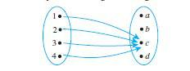

a. Write the domain and co-domain of G.

b. Find G(1), G(2), G(3), and G(4).

Answers:

a.Domain:{1,2,3,4} Co-Domain:{a,b,c,d}

b.G(1) = c; G(2) = c; G(3) = c; G(4) = c;

Question3 :

Let X = {2, 4, 5} and Y = {1, 2, 4, 6}. Which of the following arrow diagrams determine functions from X to Y ?

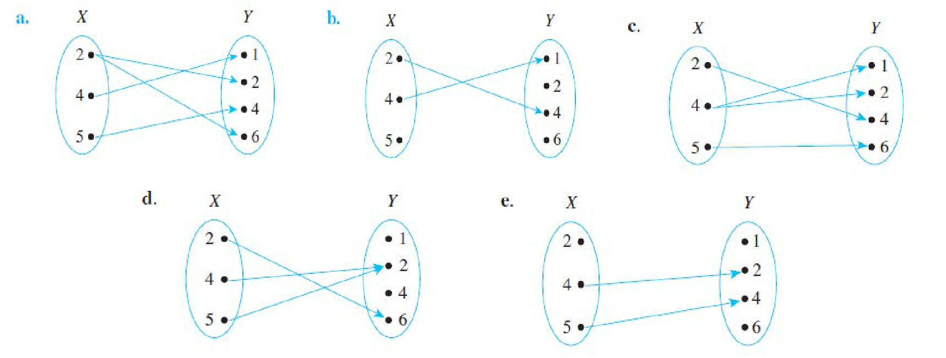

Answers:

1. B, D and E

Question 4:

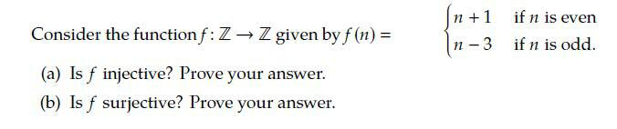

Answers:

a.f is injective because if y = n even and y = n odd then n+1 =n-3 has no solution, each input only has one output

1. f is surjective because y=n-3 even and y =n+1 odd so y can equal any integer.